A MINI PROJECT REPORT

ON

“SALARY PREDICTION USING AMCAT”
“EVALUATION”



SINHGAD COLLEGE OF ENGINEERING

DEPARTMENT OF COMPUTER ENGINEERING

SKILL DEVELOPMENT LABOTATORY

(T.E. Computer Engineering)

SUBMITTED BY

 |  | Name | Roll No.
 | 1. | Rushi Chaudhari | 305205
 | 2. | Ruturaj Chavan | 305206
 | 3. | Sujit Chavan | 305207
 | 4. | Pratik Karad | 305222

SCOE, Dept. of Computer Engineering Year 2017-18

CERTIFICATE

SINHGAD COLLEGE OF ENGINEERING

DEPARTMENT OFCOMPUTER ENGINEERING

“SALARY PREDICTION”

 |  | Name | Roll No.
 | 1. | Rushi Chaudhari | 305205
 | 2. | Ruturaj Chavan | 305206
 | 3. | Sujit Chavan | 305207
 | 4. | Pratik Karad | 305222

 | Prof. S. H. Sheikh | Prof. M. P. Wankhade
 | Internal Guide | Head of dept.
 |  | Department of Computer Engg.
Prof. S. D. Lokhande
Principal

SCOE, Dept. of Computer Engineering Year 2017-18

Acknowledgement

Every orientation works has an imprint of many people and it becomes our duty to express deep gratitude for the same.

During the entire duration of preparation for this Dissertation, we received endless help from a number of people and feel that this report would be incomplete if we do not convey graceful thanks to them. This acknowledgement is a humble attempt to thanks all those who were involved in the project work and were of immense help to us.

First and foremost we take the opportunity to extend our deep heartfelt gratitude to our guide Prof. S. H. Sheikh for guiding us throughout the entire project and for his kind and valuable suggestions, without which this idea won’t have executed. I also humbly thank Prof. M. P. Wankhede, Head of Department of Computer Engineering, SCOE, Pune for his indispensable support, his priceless suggestions and for his valuable time. We would also like to take privilege in expressing our gratitude towards other teaching & non-teaching staff for their advice and kind cooperation.

We also thanks to managing director of Precision Systems to give this opportunity to develop application for their farm to our group.

We also thank our parents and all my colleagues for encouraging me with their valuable suggestions and motivating me from time to time. Finally, last but not the least, we would thank the almighty without whose care and blessing this work would have not completed.

SCOE, Dept. of Computer Engineering Year 2017-18

INDEX

List of figures i
Abstract ii

  - Introduction

    - Introduction to Salary Prediction [1]

    - Introduction to Python [2]

    - Problem Statement [3]

  - Project Planning & Methodology

      - Software & Hardware Requirements [4]

      - Propesed System [4]

  - Analysis & Design

      - Data Flow Diagram [5]

  - Implemention & Coding

      - Flowchart ` [6]
      - List of features [7]

      - Methods Coding [8]
      - Lasso Linear Model [10]

      - GUI Design [11]

- Result
5.1.Graphs [12]

- Conclusion [13]

- References [14]

SCOE, Dept. of Computer Engineering Year 2017-18

List Of Figures

FIG NO | FIGURE NAME
1 | DATAFLOW DIAGRAM
2 | IMPLEMENTATIONN FLOW DIAGRAM
3 | LASSO LINEAR REGRESSION GRAPH
4 | GUI DESIGN
5 | RESULT GRAPHS

SCOE, Dept. of Computer Engineering i Year 2017-18

Abstract

More than a million engineers enter the global workforce every year. A relevant question is what determines the jobs and salaries these engineers are offered right after graduation. Previous studies have shown the influence of various factors such as college reputation, grades, the field one specializes in and market conditions for specific industries. An important input which such analyses do not have is a standardized measures of job skills done at the time of completion of studies. The data could be used to make an accurate salary predictor, but also understand what influences salary and job titles in the labour market.

SCOE, Dept. of Computer Engineering ii Year 2017-18

1. INTRODUCTION

1.1. Introduction To Salary Prediction

In this project we were interested to see what factors can predict success after graduating from college. To address this question we look at a dataset of engineers in India that includes information about their credentials, high school grades, college attended, BE/B.Tech GPA, English proficiency, AMCAT score (a standardized test in India to measure students skills), personal skills (derived from a personality test) , city they went to college and so on. To narrow down our question, we look at starting salary.

Our analysis depicts how these variables interact with salary, and essentially predict the salary for new candidates knowing their credentials. Using our models on the training data we are going to predict dependent variables on the test data. Later we look at our solution to extract features with highest effect on predicting salary.

This analysis could be used to give recommendation system on the basis of our data to see what factors are most important to affect one’s salary. In order to answer these questions, we used a Lasso Linear regression models to predict exact values for our dependent variables (salary).

SCOE, Dept. of Computer Engineering 1 Year 2017-18

1.2. Introduction To Python

Python is a widely used high-level programming language for general-purpose

programming, created by Guido van Rossum and first released in 1991. An interpreted language,

Python has a design philosophy that emphasizes code readability (notably

using whitespace indentation to delimit code blocks rather than curly brackets or keywords), and a syntax that allows programmers to express concepts in fewer lines of code than might be used in languages such as C++ or Java. The language provides constructs intended to enable writing clear programs on both a small and large scale.

Python features a dynamic type system and automatic memory management and supports multiple programming paradigms, including object-oriented, imperative, functional programming, and procedural styles. It has a large and comprehensive standard library.

Python interpreters are available for many operating systems, allowing Python code to run on a wide variety of systems. CPython, the reference implementation of Python, is open source software and has a community-based development model, as do nearly all of its variant implementations. CPython is managed by the non-profit Python Software Foundation.

SCOE, Dept. of Computer Engineering 2 Year 2017-18

1.3. Problem Statement:

For every engineer, AMEO dataset provides anonymised bio data information along with their respective skill scores and employment outcome information. Specifically, the following information is available for every engineer:
- Scores on Aspiring Minds' AMCAT - a standardized test of job skills. The test includes cognitive, domain and personality assessments.
- Personal information like gender and date of birth.
- Pre-university information like 10th and 12th grade marks, board of education and 12-th grade graduation year.
- University information like GPA, college major, college reputation proxy, graduation year and college location.

SCOE, Dept. of Computer Engineering 3 Year 2017-18

- PROJECT PLANNING & METHODOLOGY

    - Software & Hardware Requirements

  - Software

1. matplotlib

2. linear_model
3. sklearn-train_test_split

4. LabelEncoder

5. pandas

6. numpy

7. Ridge

  - Hardware

      - Node Component (PC/Laptop)

      - Internet Connection

    - Propesed System

Our aim to create software that analyzes previous data of certain students with help of certain parameters that affect salary value.
We are going to implement these values in machine learning algorithms. This will also help to determine the salary that particular student will have in near future. We will determine the salary with the help of Lasso Linear Regression algorithm.

SCOE, Dept. of Computer Engineering 4 Year 2017-18

3. ANALYSIS & DESIGN

3.1 Dataflow Diagram:-

Students Data

Lasso Linear Regression

Predicted Salary Value

FIG.1 DATAFLOW DIAGRAM

SCOE, Dept. of Computer Engineering 5 Year 2017-18
  - IMPLEMENTION & CODING

- Flowchart:-

Star

Start

Enter list of known Professional Skills

Pass the skills to Lasso Linear algorithm

Fit the passed values to imported linear model

Predict the Salary

Stop

FIG.2 IMPLEMENTATION FLOW DIAGRAM

SCOE, Dept. of Computer Engineering 6 Year 2017-18

s4.2 List of Features:-

- 10 th Percentage - 80,85.6

- 12th Percentage - 78.3,65.7

- Gender - m/f

- Designation - system engineer, assistant manager

- Speilization - computer engineering, information technology

- CollageGPA - 78,65.8

- English - 540,652

- Logical - 320,456

- Quantitative - 850,620

- Conscientiousness - 0.785,-0.658

- Agreeableness - 0.584,-0.956

- Extraversion - 0.412,-0.325

- Nueroticism - 0.654,-0.568

- Openess To Experience - 0.258,-0.684

SCOE, Dept. of Computer Engineering 7 Year 2017-18

4.3 Methods Coding:-

Fetching the data from CSV file:

file=pd.read_csv("train.csv",usecols=["Designation","Gender","10percentage","12percentage", "Degree","Specialization","collegeGPA","English","Logical","Quant","conscientiousness","agreeableness","extraversion","nueroticism","openess_to_experience"])  y_test=pd.read_csv("train.csv",usecols=["Salary"])  de=(file["Designation"])  ge=(file["Gender"])  tper=(file["10percentage"])  twper=(file["12percentage"])  dg=(file["Degree"])  sp=(file["Specialization"])  co=(file["collegeGPA"])  en=(file["English"])  lo=(file["Logical"])  qa=(file["Quant"])  cs=(file["conscientiousness"])  ag=(file["agreeableness"])  ex=(file["extraversion"])  nu=(file["nueroticism"])  oe=(file["openess_to_experience"])  SCOE, Dept. of Computer Engineering 8 |  | Year 2017-18

Plotting the graph formed by Linear Regression:-

fig = plt.figure(figsize=(18, 12))
sub1 = fig.add_subplot(351)
sub1.scatter(de,ybk)
sub1 = fig.add_subplot(352)
sub1.scatter(ge,ybk)
sub1 = fig.add_subplot(353)
sub1.scatter(tper,ybk)
sub1 = fig.add_subplot(354)
sub1.scatter(twper,ybk)
sub1 = fig.add_subplot(355)
sub1.scatter(dg,ybk)
sub1 = fig.add_subplot(356)
sub1.scatter(sp,ybk)
sub1 = fig.add_subplot(357)
sub1.scatter(co,ybk)
sub1 = fig.add_subplot(358)
sub1.scatter(en,ybk)
sub1 = fig.add_subplot(359)
sub1.scatter(lo,ybk)
sub1 = fig.add_subplot(3,5,10)
sub1.scatter(qa,ybk)
sub1 = fig.add_subplot(3,5,11)
sub1.scatter(cs,ybk)
sub1 = fig.add_subplot(3,5,12)
sub1.scatter(ag,ybk)
sub1 = fig.add_subplot(3,5,13)
sub1.scatter(ex,ybk)
sub1 = fig.add_subplot(3,5,14)
sub1.scatter(nu,ybk)
sub1 = fig.add_subplot(3,5,15)
sub1.scatter(oe,ybk)

Predicting Salary using Linear Regression:-

X_train, X_test, y_train, y_test = train_test_split(X, y_test, test_size=0.10)

reg = linear_model.Lasso(alpha=.01,selection='random')
reg.fit(X_train,y_train)
pp=reg.predict(X_test)

SCOE, Dept. of Computer Engineering 9 Year 2017-18

4.4 Lasso Linear Model:-

In statistics and machine learning, lasso (least absolute shrinkage and selection operator) (also Lasso or LASSO) is a regression analysis method that performs both variable selection and regularization in order to enhance the prediction accuracy and interpretability of the statistical model it produces.
Though originally defined for least squares, lasso regularization is easily extended to a wide variety of statistical models including generalized linear models, generalized estimating equations in a straightforward fashion. Lasso’s ability to perform subset selection relies on the form of the constraint and has a variety of interpretations including in terms of geometry.

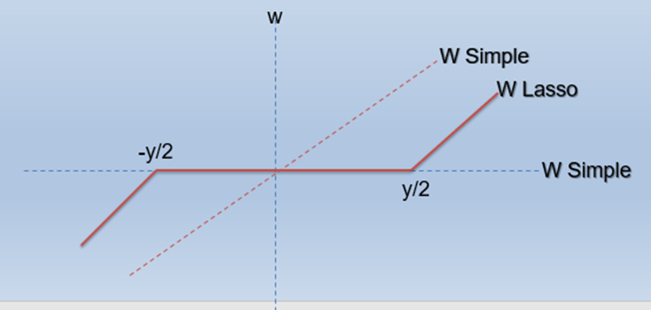

FIG.3 LASSO LINEAR REGRESSION GRAPH

SCOE, Dept. of Computer Engineering 10 Year 2017-18

4.5 GUI Design:-

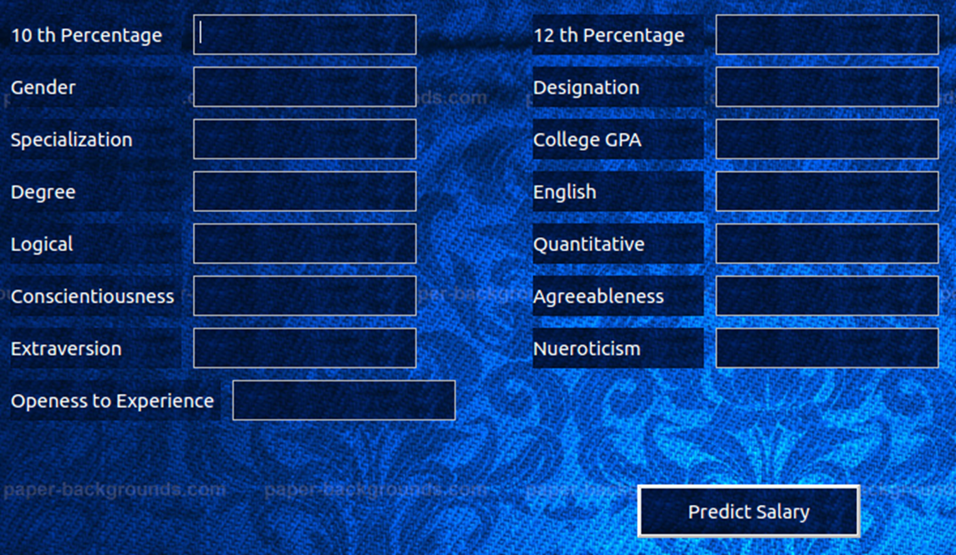

FIG.4 GUI DESIGN

Here user will enter the professional skills and clicking the ‘Predict Salary’ button, he will get predicted salary.

SCOE, Dept. of Computer Engineering 11 Year 2017-18

- Result

5.1 Graphs:-

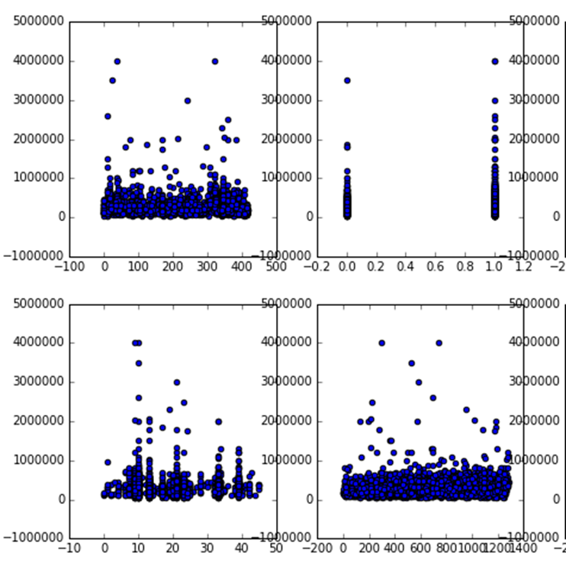

FIG.5
a) 10th Percentage VS Salary
b) 12th Percentage VS Salary
c) College GPA VS Salary
d) Degree VS Salary

SCOE, Dept. of Computer Engineering 12 Year 2017-18

6. CONCLUSION

In this project we looked at a dataset of engineering candidates in India. Each individuals’ credentials along with job salary is provided in the dataset. After cleaning up the data and feature engineering, we ended up having 15 features.
First we used regression to predict salary for each individual. Out of all Regression Models we used Lasso Linear Regression Model. We observed that Designation, Gender, 10Th%, 12Th%, Degree, Specialization, collegeGPA, English, Logical, Quant, conscientiousness, agreeableness, extraversion, nueroticism, openess_to_experience .etc predominantly affect the salary.

SCOE, Dept. of Computer Engineering 13 Year 2017-18

7. REFERENCES:-

- http://scikit-learn.org/stable/modules/linear_model.html#lasso
- https://pandas.pydata.org/pandasdocs/stable/generated/pandas.read_csv.html
- https://matplotlib.org/api/pyplot_api.html
- https://matplotlib.org/devdocs/api/_as_gen/matplotlib.pyplot.scatter.html

SCOE, Dept. of Computer Engineering 14 Year 2017-18

